# **Tasks**

**Objective Questions**:

1. What is the total no. of tables present in the data?

**Answer:**

Total no. of tables present in the data are 2, 1st one is Raw Data and 2nd one is country description.

1. What is the total no. of attributes present in the data?

**Answer:**

In the sheet named Raw data there are 20 attributes which are RestaurantID, RestaurantName, CountryCode, City, Address, Locality, LocalityVerbose, Longitude, Latitude, Cuisines, Currency, Has_Table_booking, Has_Online_delivery, Is_delivering_now, Switch_to_order_menu, Price_range, Votes, Average_Cost_for_two, Rating,Datekey_Opening.

In the sheet named Country description there are 2 attributes which are Country Code and Country Name.

1. How many categorical columns are there in the data? [Search about categorical and continuous data, and try to answer this question]

**Answer**:

Including both sheets there are 16 categorical columns, they are - RestaurantID, RestaurantName, CountryCode, City, Address, Locality, LocalityVerbose, Cuisines, Currency, Has_Table_booking, Has_Online_delivery, Is_delivering_now, Switch_to_order_menu, Price_range, Votes, Country name.

1. The data consists of some inconsistent and missing values so ensure that the data used for further analysis is cleaned.

**Answer:**

The data consists of missing values in the column of “Cuisines”. For cleaning purposes, I applied a filter for this column and found blank values, and filled all the empty cells with the common cuisine “Food”. In this way I successfully cleaned the given data for further analysis.

1. Using the LookUp functions, fill up the countries in the original data using the country code.

**Answer**: LookUp function used: =XLOOKUP(C2,'country description'!$A$2:$A$16,'country description'!$B$2:$B$16,0)

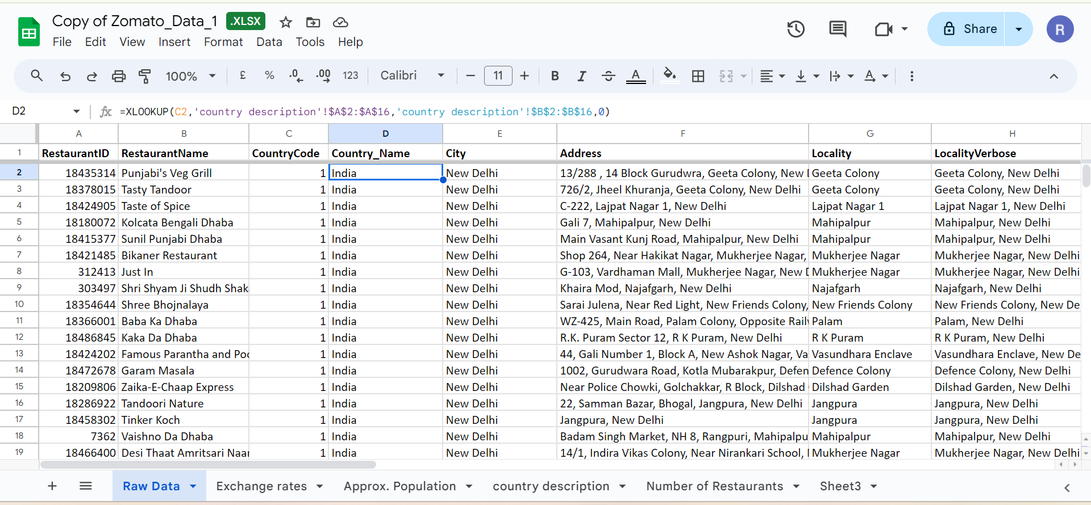

1. Create a table to represent the number of restaurants opened in each country.

| 6) Number of restaurants in each Country | |
| --- | --- |
|  |  |
| *Country_Name* | COUNTA of RestaurantID |
| Australia | 24 |
| Brazil | 60 |
| Canada | 4 |
| India | 8652 |
| Indonesia | 21 |
| New Zealand | 40 |
| Philippines | 22 |
| Qatar | 20 |
| Singapore | 20 |
| South Africa | 60 |
| Sri Lanka | 20 |
| Turkey | 34 |
| United Arab Emirates | 60 |
| United Kingdom | 80 |
| United States of America | 434 |
| **Grand Total** | **9551** |

1. Also, the management wants to look at the number of restaurants opened each year, so provide them with something here.

**Answer:**

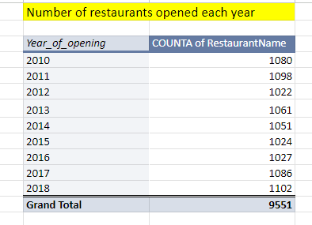

1. What is the total number of restaurants in India in the price range of 4?

**Answer:** Formula used to find total number of restaurants in India in the price range of 4: =COUNTIFs('Raw Data'!D:D,"India",'Raw Data'!R:R,"4")

Total number of restaurants in India in the price range of 4: **388**

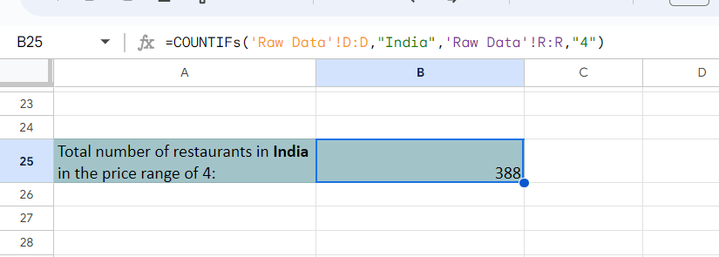

1. What is the average number of voters for the restaurants in each country according to the data?

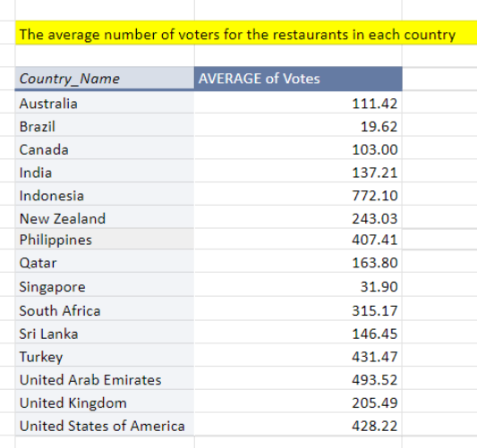

1. Calculate the average rating for all the restaurants that have price_range < 4 and provide online delivery. Use only the “IF” function, Logical Operators, and Aggregation functions to solve this problem. **[Note: Don’t use Conditional aggregation in this question.]**

**Answer:** Average rating for all the restaurants that have price_range < 4 and provide online delivery is 2.89

Formula used to find average rating for all the restaurants that have price_range < 4 and provide online delivery: =IF(AND(R2<4,O2="Yes"),AVERAGE(X:X),"Unsatisfied Condition")

1. Using Conditional formatting highlight the rows of restaurants that are located in the countries or cities that you’ve suggested to the management for opening new restaurants.

**Answer:**

By using Conditional formatting I highlighted the names of some cities (column E) which have an overall count less than 10. For this I used a “custom formula” for counting the number of cities. Basically I’m counting the number of restaurants for each city if the count is less than 10 means there is less competition for opening newer restaurants in that particular city.

Custom formula used: =COUNTIF($E$2:$E$9552,$E2)<10

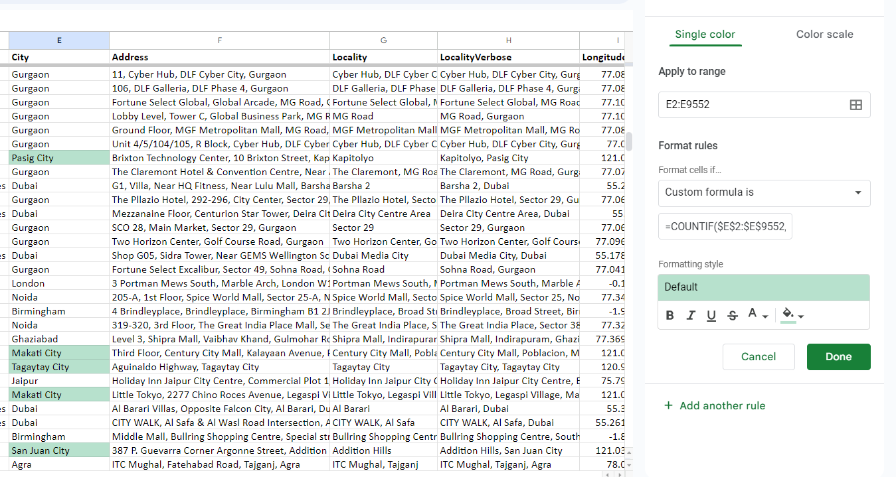

1. Create a new customised price column that consists of the abbreviation/symbol of the currency along with the Average_cost_for_two value. [Use string operations to do this task]

**Answer:**

I have created customised price column(W) by concatenating the column “Currency symbol” and “Average_cost_for_two”

Formula: =CONCATENATE(M2,T2)

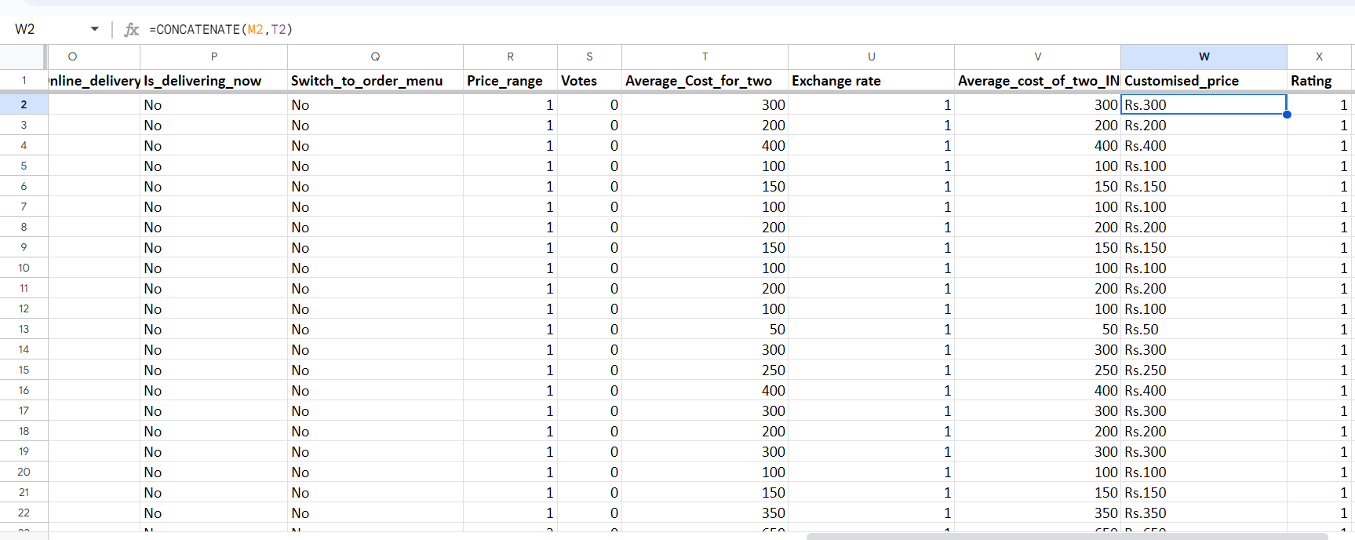

1. How can you create an array formula in Excel or Google Sheets to count the number of restaurants listed that do not offer online delivery, are in the lowest price range, and have an average cost for two people less than or equal to 250 Indian Rupees?

**Answer:**

To create an array formula to count the number of restaurants listed that do not offer online delivery, are in the lowest price range, and have an average cost for two people less than or equal to 250 Indian Rupees, I used conditional aggregation “Countifs” with array formula.

Formula used:=ArrayFormula(COUNTIFS('Raw Data'!O:O,"No",'Raw Data'!R:R,"1",'Raw Data'!V:V,"<=250",'Raw Data'!L:L,"Indian Rupees(Rs.)"))

| 13)To count the number of restaurants with no online delivery, price range 1, average cost for two people<=250 Indian Rupees | | 1685 |
| --- | --- | --- |
|  |

**Subjective Question:**

1. Suggest a few countries where the team can open newer restaurants with lesser competition. Which visualisation/technique will you use here to justify the suggestions?

**Answer:**

According to me, We cannot suggest countries to open new restaurants only by looking at “Total number of restaurants in each country” , so I calculated restaurants per capita by comparing approx. population and number of restaurants for each country. Lesser the value of restaurants per capita there would be lesser competition. And also by putting the 2nd criteria that the average rating must be less than 4 for that particular country, So by combining both the conditions I fetched some countries named- *India, Singapore, Australia, Brazil, Canada, Sri Lanka.*

**Condition:**

1. Restaurants per capita <0.000007
2. Avg. rating <4

**Formula Applied:**

**=IF(AND(D2<0.000007,E2<4),"Suggested","Not Suggested")**

So, I suggested countries where restaurants per capita is less(indicating less competition) and also countries having less average ratings so that there is more scope for opening newer restaurants with lesser competition.

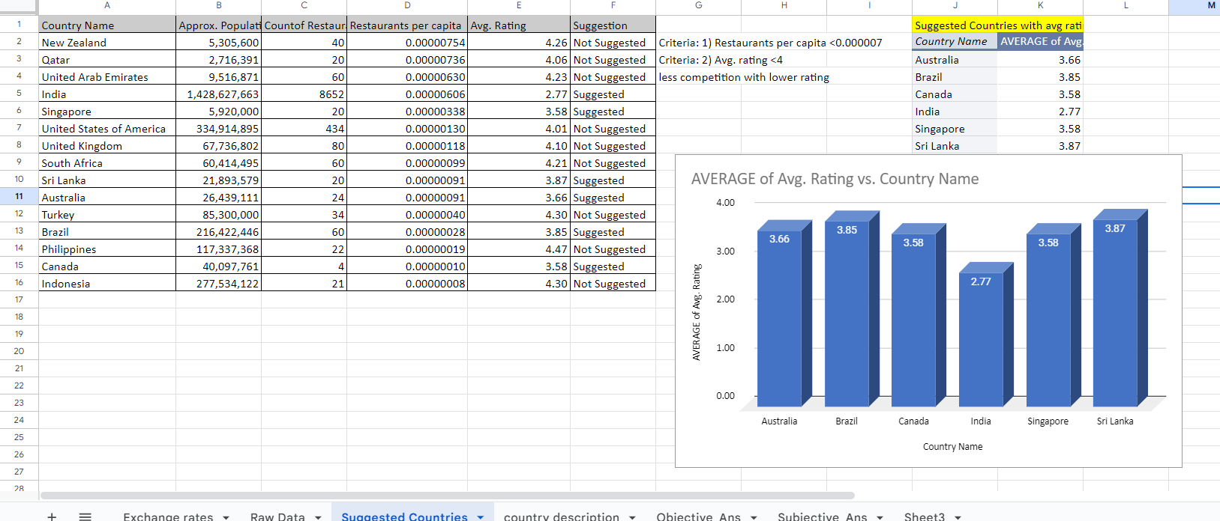

1. Come up with the names of States and cities in the suggested countries suitable for opening restaurants.

**Answer:**

For fetching cities for the suggested countries , firstly I dragged Countries and cities in row part and applied filter for the 6 suggested countries and noted the names of the countries which belong to the respective countries.

From suggested countries, there are 75 cities, names of cities are- Armidale, Balingup, Beechworth, Dicky Beach, East Ballina, Flaxton, Forrest, Hepburn Springs, Huskisson, Inverloch, Lakes Entrance, Lorn, Macedon, Mayfield, Middleton Beach, Montville, Palm Cove, Paynesville, Penola, Phillip Island, Tanunda, Trentham East, Victor Harbor, Brasí_lia, Rio de Janeiro, Sí£o Paulo, Chatham-Kent, Consort, Vineland Station, Yorkton, Colombo, Agra, Ahmedabad, Allahabad, Amritsar, Aurangabad, Bangalore, Bhopal, Bhubaneshwar, Chandigarh, Chennai, Coimbatore, Dehradun, Faridabad, Ghaziabad, Goa, Gurgaon, Guwahati, Hyderabad, Indore, Jaipur, Kanpur, Kochi, Kolkata, Lucknow, Ludhiana, Mangalore, Mohali, Mumbai, Mysore, Nagpur, Nashik, New Delhi, Noida, Panchkula, Patna, Puducherry, Pune, Ranchi, Secunderabad, Surat, Vadodara, Varanasi, Vizag, Singapore

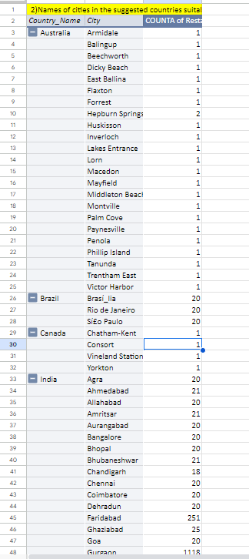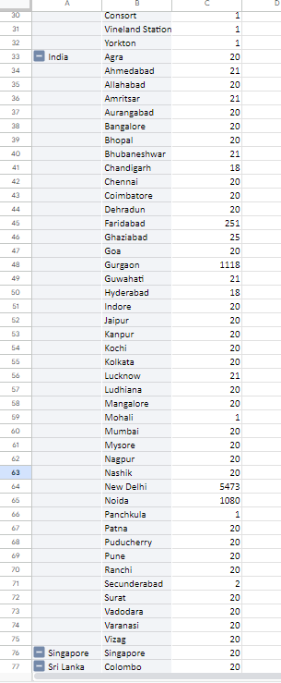

1. According to the countries you suggested, what is the current quality regarding ratings for restaurants that are open there?

**Answer:**

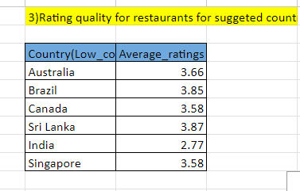

According to the suggested countries, the current quality of ratings for the restaurants that are already open there *is lower than 4* .

For this I have calculated average ratings for each suggested country.

1. Also, what is the current expenditure on food in the suggested countries, so we can keep our financial expenditure in control?

**Answer:** I have calculated the current expenditure on food for the suggested countries by taking the average of “average cost for two” after converting the different currencies into Indian rupee(INR) (for easy and proper comparison), with respect to every suggested country as shown in below the image .

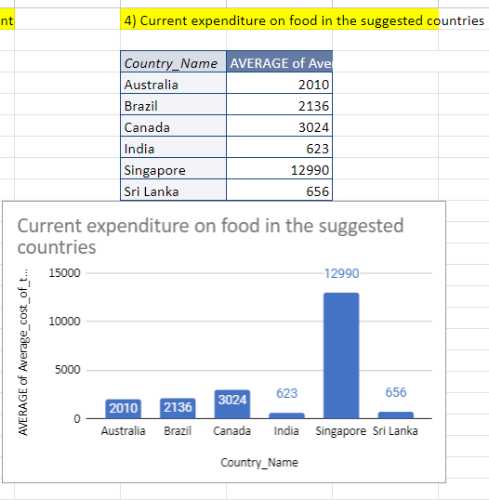

1. *India (INR 623)* is the most budget-friendly option on the list.
2. Similar to India, *Sri Lanka (INR 656)* offers a relatively affordable dining experience for two.
3. Food costs in *Brazil (INR 2136***)** are moderately higher than India and Sri Lanka.
4. Budgeting for food expenses will be more significant in *Canada (INR 3024.*
5. *Singapore (INR 12990)*is the most expensive option on this list.
6. Come up with the names of restaurants from the recommended states that are our biggest competitors and also those that are rated in the lower brackets, i.e. 1-2 or 2-3.

**Answer:**

For fetching names of restaurants, firstly i created pivot table in that i applied filter for the suggested countries India, Singapore, Australia, Brazil, Canada, Sri Lanka and also applied filer for the ratings , before that i grouped the ratings in 1-2 , 2-3, 3-4, 4-5 and in this way you can see the result as below

Names of the Restaurants those having lower ratings(between1-2):

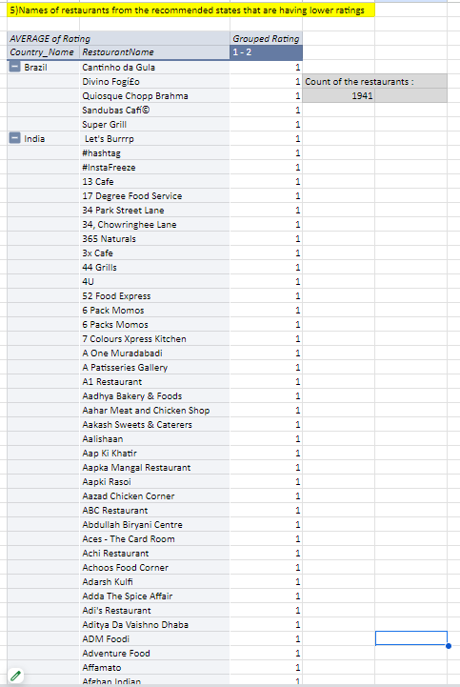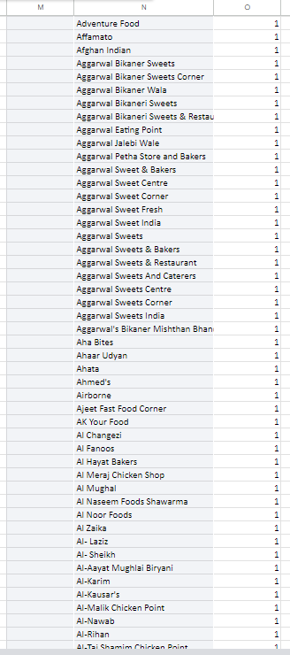

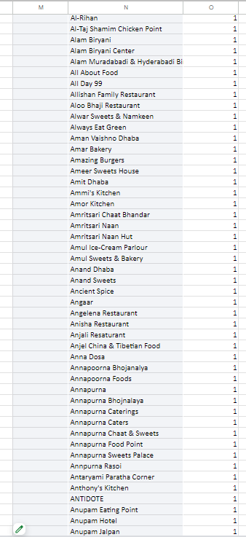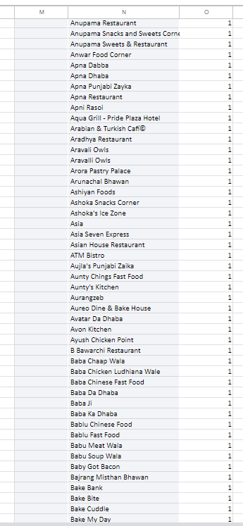

Names of the restaurants that are biggest competitor(rating>4.5) are:

Bridge Road Brewers, Aconchego Carioca, Aprazí_vel, Balada Mix, Bibi, Braseiro da Gíçvea, Cantina Famiglia Mancini, Cervantes, Coco Bambu, Confeitaria Colombo, Garota de Ipanema, Les 3 Brasseurs, Skye - Hotel Unique, Sushi Leblon, TT Burger, Veloso, Zazíç BistríÇ Tropical, Ministry of Crab, Simply Strawberries By Jagro, etc.

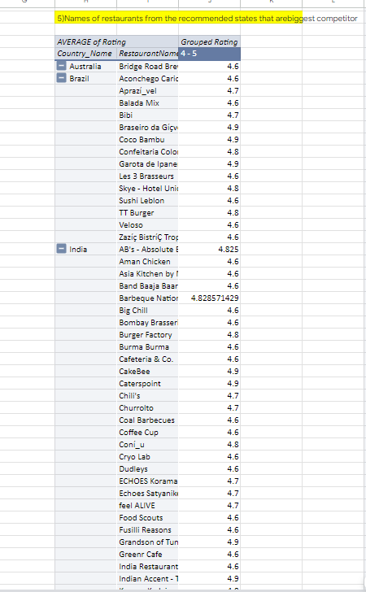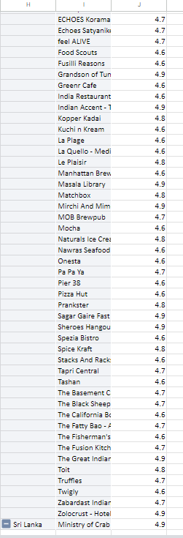

1. Which cuisines should we focus on in the newer restaurants to get better feedback? Does the choice of cuisines affect the restaurant ratings?

**Answer:**

We can find the cuisineshaving the highest number of total voting and also having the highest average ratings. I fetched cuisines having total votes greater than 4000 and average ratings greater than 4.

Choice of cuisines affect the ratings of restaurants as seen below we can observe that the cuisines having highest total votes having ratings also high.

We should focus on following cuisines:

1. American, Burger, Cafe
2. Cafe, Mexican, American, Italian, Lebanese, Continental
3. Chinese, North Indian
4. Continental, American, Asian, North Indian
5. Continental, North Indian
6. European, Mediterranean, North Indian
7. Finger Food, North Indian, Italian, Continental, Thai, South Indian
8. Italian, American, Pizza
9. Italian, Continental, European, Cafe
10. Modern Indian
11. North Indian, Chines
12. North Indian, European, Mediterranean
13. North Indian, Mughlai
14. South Indian

| 6) Cousines we should focus are: | | |
| --- | --- | --- |
| *Cuisines* | SUM of Votes | AVERAGE of Rating |
| American, Burger, Cafe | 9667 | 4.7 |
| Cafe, Mexican, American, Italian, Lebanese, Continental | 4085 | 4.3 |
| Chinese, North Indian | 5288 | 4.2 |
| Continental, American, Asian, North Indian | 7931 | 4.3 |
| Continental, North Indian | 7574 | 4.3 |
| European, Mediterranean, North Indian | 12341 | 4.75 |
| Finger Food, North Indian, Italian, Continental, Thai, South Indian | 5705 | 4.5 |
| Italian, American, Pizza | 10934 | 4.8 |
| Italian, Continental, European, Cafe | 4986 | 4.5 |
| Modern Indian | 4385 | 4.3 |
| North Indian, Chinese | 5966 | 4.9 |
| North Indian, European, Mediterranean | 5385 | 4.1 |
| North Indian, Mughlai | 4373 | 4.4 |
| South Indian | 5172 | 4.3 |

1. According to our current data, should we go for online delivery and table booking? Does that affect the customer’s ratings?

**Answer:**

According to our current data , we should definitely go for online delivery and table booking as it affects the ratings of the customers. From the image we can see that not having online delivery and not having table booking lead to decrease in ratings of customers.

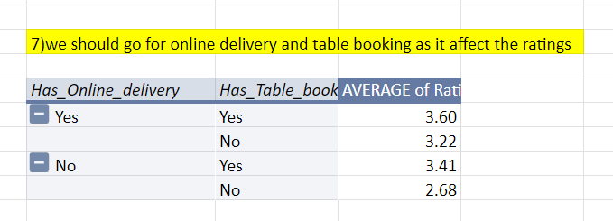

By analysing the given data, we found that

1. Restaurants ***providing online delivery*** services tend to have ***higher customer ratings***.
2. Restaurants ***without online delivery*** options receive ***lower ratings***
3. ***Availability of table booking*** correlates with ***higher ratings***
4. Restaurants ***not having table booking*** services tend to have ***lower ratings***.
5. Should the team keep the rate of cuisines higher? Will that affect the feedback? According to our data are the rates of cuisines and ratings, correlated?

**Answer:**

1. The correlation between the rates of cuisines and ratings is 0.463. Based on the moderate positive correlation of 0.463, I can suggest that keeping the rate of cuisines higher may positively increase customer ratings. However, the correlation is moderate and not strong, this should not be the only strategy.
2. There is a moderate positive correlation between higher rates of cuisines and better customer feedback. This means that increasing the prices of cuisines is likely to improve customer ratings because customers often think higher prices mean better quality.
3. Yes, according to the data, there is a moderate positive correlation of 0.46 between the rates of cuisines and customer ratings. This indicates that there is a tendency for higher-rated cuisines to receive better customer ratings, although the relationship is not very strong.
4. For correlation formula used: =CORREL('Raw Data'!R:R,'Raw Data'!X:X)

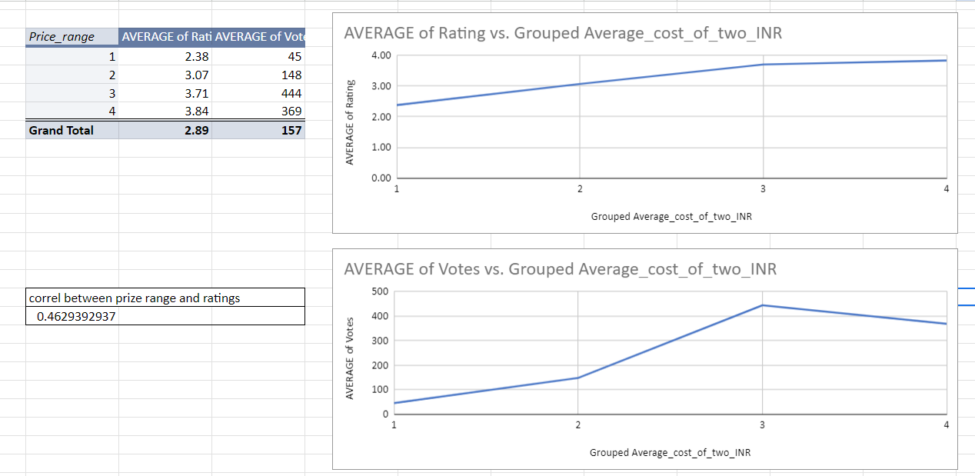

1. What is the distribution of the number of restaurants of different price ranges in all the countries?

**Answer:**

For the distribution of the number of restaurants of different price ranges for all countries, firstly I dragged country names in row and price ranges in column and count of restaurants in values. And inserted a Chart for distribution.

Distribution of the number of restaurants of the the price range 1, 2, 3, 4 for all 15 countries is:

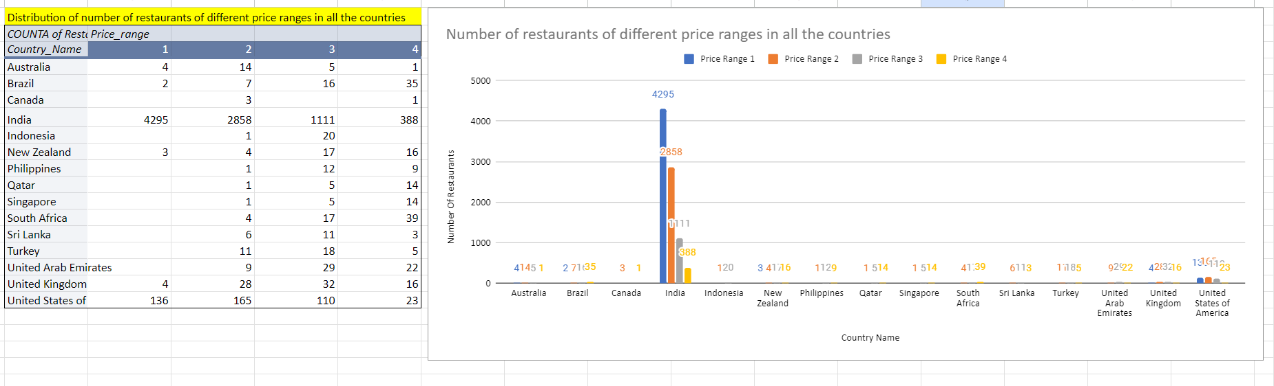

1. Explain your approach in brief for suggesting countries/cities in order to open new restaurants, if the objective and subjective questions would have not been given to assist you.

**Answer:**

* By Identifying cities/countries having less number of restaurants, which indicate potential demand in that particular country/city.
* By looking for the countries/cities having less number of average ratings, this indicates that competition is less.
* Considering the presence of table booking and online delivery options, which could impact the decision.
* By leveraging longitude and latitude data along with foot traffic and demographic information, you can strategically identify the best locations within cities to open new restaurants.
* By looking for the areas with high visibility, accessibility, and a strong presence of our target audience.
* By comparing the number of votes for different countries/cities.
* By looking at the increase in the number of restaurants over years in the different cities/countries.